Machine Learning-Based Early Prediction of Diabetes
Using a Progressive Model Comparison Approach
Ramandeep Singh (2210990714), Raninder Singh (2210990715)
Chitkara University Institute of Engineering and Technology,
Chitkara University, Punjab, India
ramandeep714.be22@chitkara.edu.in | raninder715.be22@chitkara.edu.in

ABSTRACT
It's important to accurately detect diabetes in its early stages to reduce long-term health complications. Traditional approaches of diagnosing diabetes are often time-consuming and subject to human interpretation, making them unreliable and time-consuming. In this paper, we explore the application of machine learning to diagnose diabetes through an iterative approach for modeling and evaluating the following algorithms: Logistic Regression, Decision Tree, and K-Nearest Neighbors (KNN). First, Logistic Regression was adopted as a baseline algorithm achieving an average level of accuracy but failed to pick up nonlinearly related patterns in the data. The next algorithm used was Decision Tree, which introduced non-linearity into the algorithm and is susceptible of over-fitting thereby affecting its predictive capacity. Lastly, KNN proved to be the most effective algorithm in capturing local relationships in data but it is sensitive to data scaling and time complexity. Successfully comparing the performance of different algorithms highlights the benefits and drawbacks. In conclusion, the findings have shown that future research efforts should include ensemble and hybrid approaches to further improve prediction performance. This could be achieved with ensemble models such as Boost by integrating the strengths of multiple algorithms, and further increasing the overall prediction capability of models by adding linear and non-linear elements into hybrid models.
Keywords — Diabetes prediction, machine learning, logistic regression, decision tree, K-Nearest Neighbors, KNN, classification, Pima Indians Diabetes Dataset.
I. INTRODUCTION
Diabetes is among the most common chronic diseases around the world and affecting the health system. It affects the ability of the body to regulate the level of blood glucose because it either doesn't secrete enough insulin or cannot utilize it efficiently. Early diagnosis and treatment of diabetes are essential because the pandemic may lead to other illnesses, such as cardiovascular diseases, renal failure, damages in nerves, and blindness. High prevalence (incidence) of the disease, due to sedentary lifestyles, unhealthy diets and genetic factors, highlight the existence of effective diagnostic techniques.
The traditional methods of diagnosing diabetes including clinical examination and medical expertise, which are costly in terms of time and money, and may even be unreliable. In many developing countries, where there are limited medical facilities and patients are required to wait for a long time for a diagnosis, early diagnostics is still a challenge. These days, thanks to data-driven technologies, machine learning is a powerful tool that can be used to aid medical data analysis and develop better models.
In this paper, we will discuss the application of machine learning techniques to model the condition of diabetes with some related clinical factors such as blood glucose level, body mass index (BMI), level of insulin and age. This study employs the concept of a design by adding complexity to the models progressively to show their superiority in terms of performance. This study offers insight on the advantages or disadvantages of using certain prediction methods and the need for more advanced tools that can be of value in managing the disease.
II. LITERATURE REVIEW
Machine learning-based diabetes prediction has gained popularity in recent times due to the advances in the availability of medical data. The need for early diagnosis provided a driving force to develop various algorithms to enhance the accuracy of early prediction. A widely used dataset for the study of diabetes prediction is the Pima Indians Diabetes Dataset because it has some clinically relevant features, such as glucose, BMI, insulin, age and blood pressure.
The initial methods mainly employed conventional machine learning algorithms such as Logistic Regression, Support Vector Machine, and Decision Trees. The main reasons of using these algorithms are the easy to understand and acceptable prediction performance. Many researchers have used Logistic Regression for its probability prediction, but it is not able to account for complex interaction between the medical variables.
To overcome the disadvantages of conventional algorithms and improve prediction capabilities of diabetes, researchers proposed Random Forest and K-Nearest Neighbors (KNN). Random Forest substantially enhances the classification predictive capability of decision trees by aggregating different decision trees. The KNN approach has been found to be highly sensitive to scaling and with high computational time.
Recent developments have been focused in the area of ensemble and boosting methods, in particular the use of the Boost technique that is extremely efficient in most applications. This approach can handle missing data, identify complex inter-relations in the data, and control overfitting (regularization). Most studies show an accuracy of greater than 85-90% in diabetes database. Artificial Neural Networks (ANN) can however achieve higher accuracies, but need more data.
Indeed the literature review demonstrates that the prediction efficiency of the models significantly depends not only on the algorithm used but also on the data pre-processing techniques, such as feature selection, normalization, and implementation of methods to handle the imbalance of classes, such as SMOTE. Despite significant progress in recent years, there are still some challenges. This literature review highlights the development of machine learning from linear models to ensemble models which also makes a good foundation for the current study, which aims to investigate different models and find the best one for diabetic predictions.
III. METHODOLOGY
In this research work, the design of an efficient machine learning algorithm based solution for diabetes prediction is proposed. For this study, the Pima Indians Diabetes Dataset is adopted, which is a well-known and benchmark dataset for the healthcare industry. Various physiological attributes like glucose level, insulin level, body mass index (BMI), Diabetes Pedigree Function, and age are included in the dataset, which are highly related to the prediction of diabetes.
Before any modelling, data pre-processing is carried out and this plays an important role in boosting the predictive performance of models. The data is checked for inconsistencies in the data and missing values. For example, in healthcare data, some features can include 0's, which represent missing values. These values are replaced through imputation, or by the mean of the feature values. Also, irrelevant features such as Skin thickness and Blood pressure are removed. Lastly, feature scaling is done using normalization or standardization to enhance the results, particularly in the case of distance-based classifiers such as K-Nearest Neighbors.
Once preprocessed, the data is split into training and test sets with a ratio of 80:20 respectively. This allows assessment of the generalization performance of the models constructed and prediction performance of unseen data. The experiments are made reproducible by specifying a random state.
A progressive approach is taken for model development where various machine learning algorithms are used to compare the performance of algorithms in predicting diabetes. Logistic Regression is used as a basic model. To overcome its weakness in capturing interactions between predictors, a Decision Tree model is used to capture the etc. However, Decision Trees tend to overfit data, which is detected via regularization. Finally, a tuned KNN algorithm is chosen based on the optimal size of neighbors (found using the elbow method).
To enhance the model's robustness, models are fine-tuned using hyperparameter optimization. For KNN, different values of k are tested to reach a good balance between the bias and the variance. Other models, such as Decision Tree, have parameters (e.g.: tree depth) tuned to prevent overfitting.
The performance of all Models is measured by multiple metrics. Accuracy measures the overall success of predictions; Precision and F1-Score are useful to assess classifier performance on unbalanced (skewed) data. Root Mean Squared Error (RMSE) measures average error of predictions, whereas the R² Score is used to measure the explanatory power of the model. The entire process flow of the proposed research is outlined as follows:
Data Acquisition → Data Pre-processing → Feature Selection → Data Splitting
→ Model Training → Hyperparameter Optimization → Model Evaluation → Model Comparison
IV. RESULTS AND DISCUSSION
The built machine learning models have been assessed using a set of metrics, i.e. Accuracy, Precision, F1-Score, RMSE and R² Score. This enabled a comprehensive assessment of the accuracy of predictions. The conducted project used a step-by-step evaluation of the various algorithms' impact on the diabetes dataset and which one is the most effective. As shown in Fig.1.
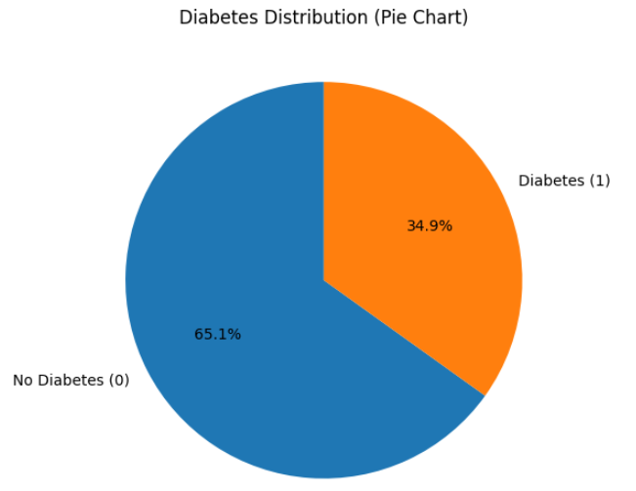
Figure 1. Diabetes class distribution in the Pima Indians Diabetes Dataset.
The first attempt was to use Logistic Regression and Decision Tree. Although Logistic Regression was stable and highly consistent, it was not the optimal algorithm as it was linear, and did not account for non-linear interactions between the predictors including glucose, BMI and insulin. The Decision Tree algorithm considered these relationships, but it was easily overfitted and did not have a good capacity for generalization. As shown in Fig.2.
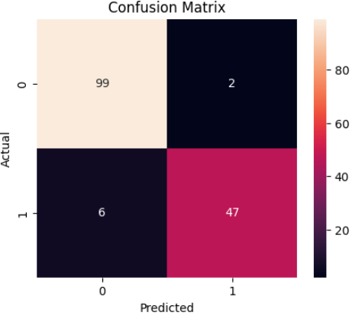
Figure 2. Confusion matrix for the baseline classification model.
To improve the model, complex models were implemented. The Random Forest model was more robust and was better at capturing feature interactions, leading to an Accuracy of 77.27%, Precision of 0.7368 and F1-Score of 0.6153. The RMSE for this model continued to be in the moderate range (0.47-0.52) and R² Score was negative (as it always is for classification problems with limited variance explanation). Random Forest performed better than Decision Tree and had less overfitting because of the ensemble of trees. As shown in Fig.3.

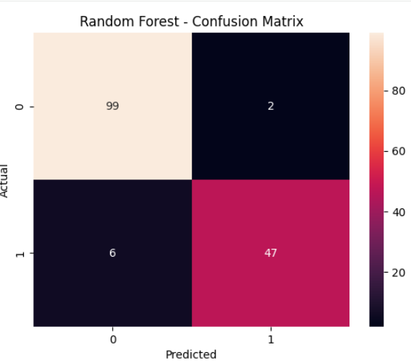
Figure 3. Confusion matrix for the Random Forest model.
Even better results were achieved with the optimized K-Nearest Neighbors (KNN), which had the best performance of the models used. The KNN model had 79.87% Accuracy, 0.8437 Precision and 0.6353 F1-Score, outperforming the Random Forest model. The KNN model also resulted in a slightly lower RMSE (around 0.45-0.50). The better performance is due to the effectiveness of this model in capturing local patterns in the data after scaling and hyper parameter tuning of the model. However, the R² Score was still close to 0. As shown in Fig.4.

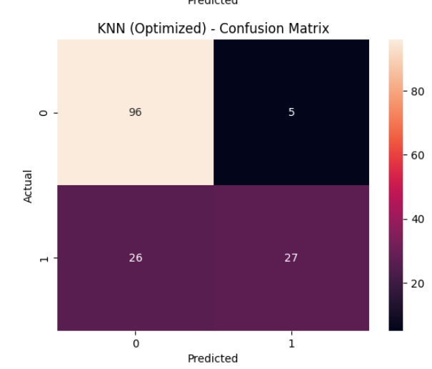
Figure 4. Confusion matrix for the optimized KNN model.
It is evident from the above comparative study that the performance of the models has improved. The baseline models introduce a first-order understanding of the problem and then ensemble learning and distance-based models improve prediction performance. The tuned KNN model has correctly ranked models with highest predictive accuracy and lowest errors.
In conclusion, model, pre-processing and optimization techniques play a critical role in obtaining good prediction accuracy. The optimized KNN model has given the best performance in this research work, but better accuracy could be obtained by using a boosting method or combining the models.
V. CONCLUSION
A machine learning based approach has been presented in this work for the development of early detection of the possibilities of diabetes. A comprehensive modeling process was adopted to examine the effectiveness of a variety of algorithms, from naive to sophisticated models. The Pima Indians Diabetes Dataset was chosen to incorporate the required features to enable the development of analytical and predictive models.
The results show that while baseline models like Logistic Regression and Decision Tree can predict, they are limited in their ability to model complex relationships in the data set. Specifically, the Decision Tree model was overfitted. The inclusion of the Random Forest model improved stability and predictions. Moreover, the K-Nearest Neighbors (KNN) model - after parameter tuning - has been identified as the best model in this research.
Through statistical comparison, it was determined that while traditional and intermediate models can provide reliable results, they cannot match the accuracy of the best-performing models such as ensemble techniques (e.g. boosting) that have been used in recent studies.
Machine learning algorithms clearly exhibit effectiveness in diagnosing diabetes and assisting clinical decision-making. Researchers may explore future studies including advanced models such as Boost, hybrid or deep learning methods, as well as real-time monitoring of patients to improve the accuracy and the ability to use the prediction in a clinical environment.
REFERENCES
[1] International Diabetes Federation, IDF Diabetes Atlas, 10th ed., Brussels, Belgium, 2021.
[2] S. Akhtar, M. K. Nasir, and S. Sarwar, "Prevalence of diabetes and pre-diabetes: A systematic review," BMJ Open, vol. 10, no. 4, 2020.
[3] J. W. Smith, J. E. Everhart, W. C. Dickson, W. C. Knowler, and R. S. Johannes, "Using the ADAP learning algorithm to forecast the onset of diabetes mellitus," in Proc. Symposium on Computer Applications in Medical Care, 1988.
[4] A. Géron, Hands-On Machine Learning with Scikit-Learn, Keras, and TensorFlow, 2nd ed. O'Reilly Media, 2019.
[5] T. M. Mitchell, Machine Learning. McGraw-Hill, 1997.
[6] H. Mohan and V. Jain, "Performance analysis of support vector machine in diabetes prediction," International Journal of Computer Applications, vol. 176, no. 32, 2020.
[7] K. VijiyaKumar, N. Lavanya, and S. Prakash, "Random forest algorithm for diabetes prediction," International Journal of Innovative Technology and Exploring Engineering, vol. 8, no. 6, 2019.
[8] P. Prabhu and S. Selvabharathi, "Deep belief neural network model for diabetes prediction," Procedia Computer Science, vol. 165, 2019.
[9] J. Cervantes, F. Garcia-Lamont, L. Rodríguez-Mazahua, and A. Lopez, "A comprehensive survey on support vector machines classification," Neurocomputing, vol. 408, 2020.
[10] H. He, Y. Bai, E. A. Garcia, and S. Li, "ADASYN: Adaptive synthetic sampling approach for imbalanced learning," in IEEE Int. Joint Conf. Neural Networks, 2008.
[11] M. K. Hasan et al., "Ensemble machine learning methods for diabetes prediction," IEEE Access, vol. 8, pp. 112345–112357, 2020.
[12] H. M. Deberneh and I. Kim, "Type-2 diabetes prediction using machine learning algorithms," Applied Sciences, vol. 11, no. 9, 2021.
[13] C. C. Olisah, A. O. Adebiyi, and B. O. Adebiyi, "Diabetes prediction using preprocessing and machine learning techniques," Healthcare Analytics, vol. 2, 2022.
[14] "Comparison of Machine Learning Models for Predicting Type 2 Diabetes Risk Using the Pima Indians Diabetes Dataset," Journal of Integrated Management Research, 2025.
[15] M. Alghamdi et al., "Deep learning approach for diabetes prediction using PIMA Indian dataset," Neural Computing and Applications, vol. 32, 2020.
[16] R. Singh and R. Singh, "Machine Learning-Based Early Prediction of Diabetes for Preventive Healthcare," 2026.

